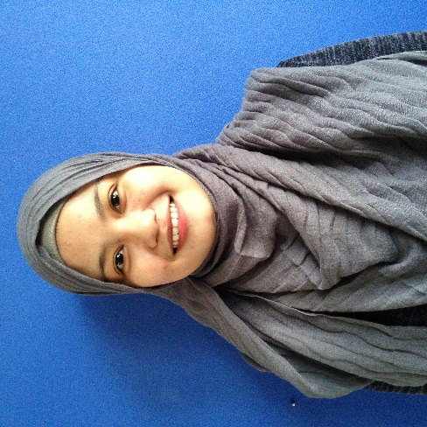

J-5-22 APARTMENT KENANGA

TAMAN BUNGA RAYA,BUKIT BERUNTUNG

48300 RAWANG, SELANGOR.

Phone: 017-237 6215

E-mail: shedaramli3@gmail.com

RASHIDAH BT MOHD RAMLI

|  |  |  |  |
| --- | --- | --- | --- |
| Objective |  |  | A self-motivated, passionate and hardworking fresh graduate seeking a position that will allow me to use my Diploma in International Business Management, strong interpersonal skills as well as it my eagerness to contribute to a quality company. I would also like to work in a professional and active environment where I can utilize my skills and strengths in an achieving goals of the company. |
| Skills & Abilities |  |  | * Proficient in Microsoft Office Word, Power Point, excel and keyboarding. * Able to work under pressure. * Able to write well in Malay and English. * Willing learn more and work independently with minimum supervision. * Able to work in group or team. * Excellent in communication * Able to work on shift operation and under challenging environment. |
| Education |  |  | DIPLOMA INTERNATIONAL BUSSINESS (2014-2017)   * Institute : Politeknik Sultan Salahuddin Abdul Aziz Shah, Shah Alam * CGPA : 2.78 * Graduated : December 2017 |
| extra curricular activities |  |  | * Committee member of Kelab Kebudayaan in Polytechnic. * Participated in English Musical Drama Competition in Polytechnic. * Participated in dance competition in polytechnic. * Crew in program X-Factor in polytechnic. |
| EXPERIENCES |  |  | Work at R&R Rawang as a cashier for 3 years.  * Work at Pizza Hut as a cashier. * Work at Aunty Anne’s as a cashier. |
| References |  |  | mr. mazrul hisyam bin ab malik Academic Advisor in Politeknik Sultan Salahuddin Abdul Aziz Shah  019-607 6700 |